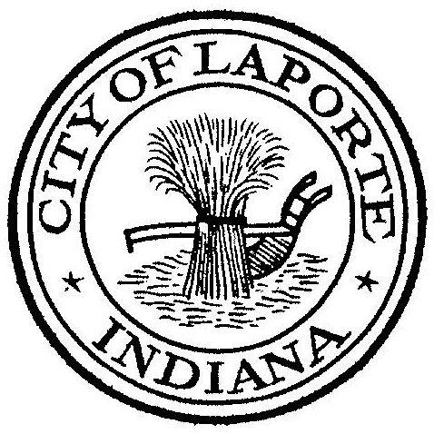
Board of Public Works and Safety
Jessica Romine, Member Tom Dermody, Mayor Mark Kosior, Member
City Hall 801 Michigan Ave., La Porte, IN 46350
Wednesday, February 21, 2024
9:00 AM
AGENDA
- Call To Order
- Pledge Of Allegiance
- Approval Of Minutes
- Public Comment: In Person and via Facebook Live
- Clerk-Treasurer: Claims Approval
Updated 2024 bakertilly Agreement
- Department Head Reports
- New Business:
-Request For Use Happy Frog
-City Attorney Agreement with Newby, Lewis, Kaminski & Jones, LLP
-Nick Minich: CMAQ Grant Agreement for Equipment Procurement
-Dick Buell: Request from K9 Handler
-Craig Phillips: INDOT-LPA Contract Addendum/Amendment
- Unfinished Business:
-Tabled: Proposal for Professional Engineering Services
- Other Business: Next regularly scheduled meeting: Tuesday, March 5, 2024 at 9a
10) Adjourn

